Test case injested into MongoDB via vector Index through embedding model
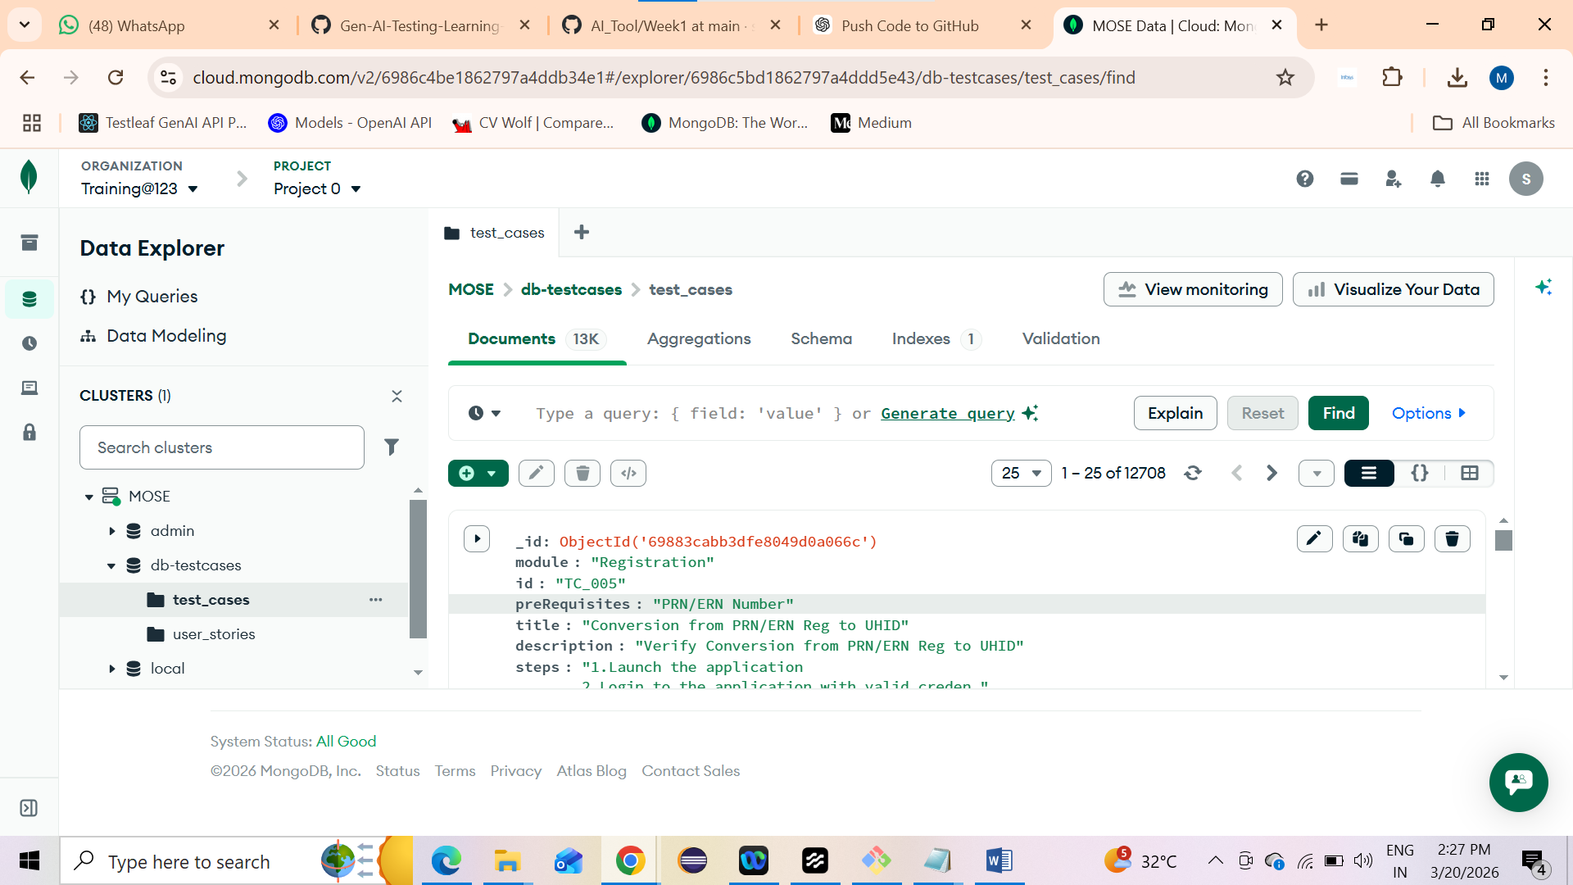

User stories injested into MongoDB via vector Index through embedding model
